IMDb Movie Rating Scraper Project Report
automation tool designed to extract real-time cinematic data
Author: NOOLU SUPRIYA(Team 3),
Project Type: Individual Project

1.EXECUTIVE SUMMARY:
The IMDb Movie Rating Scraper is a Python-based automation tool designed to extract real-time data from the IMDb Top 250 Movies list. It specifically targets dynamic web content that requires browser rendering to display correctly.By utilizing Selenium and Chrome WebDriver, the tool mimics human browsing behavior to ensure all JavaScript elements are fully loaded before data collection. This approach allows for the reliable extraction of movie titles, release years, and IMDb ratings directly into a structured CSV format.Ultimately, the exported datasets serve as a high-quality resource for movie trend analysis, building recommendation engines, or populating personal film databases.

2.PROJECT OVERVIEW:

i.Objective:

The primary goal of this project is to provide a Python-based automation tool that dynamically extracts movie data from the IMDb Top 250 list. It aims to bypass the limitations of static scraping by handling JavaScript-rendered content, ensuring that data like titles, ratings, and rankings are captured accurately as they appear to a human user.

ii.Scope:
• Single-platform focus: The tool is specifically optimized for IMDb, targeting its unique HTML structure and CSS selectors to ensure high-precision data retrieval
• Real-time data extraction: By using a live browser instance via Selenium, the scraper pulls the most current ratings and rankings directly from the web rather than relying on outdated datasets.
• Automation: By using a live browser instance via Selenium, the scraper pulls the most current ratings and rankings directly from the web rather than relying on outdated datasets.
• Data Export: The scope includes data transformation, where raw web elements are converted into a structured CSV format using the pandas library for immediate use in external applications.
iii.Key Features:
- Dynamic Scraping Engine: Utilizes Selenium to handle pages that require active rendering, allowing it to "see" content that standard scrapers might miss.
- Automated Driver Management: Integrates webdriver_manager to automatically download and configure the correct version of ChromeDriver, reducing manual setup errors.
- Headless Mode Capability: Supports a "headless" execution option, allowing the script to run in the background without a visible UI, which is ideal for scheduled tasks.
- Structured Data Output: Specifically scrapes and organizes the Movie Name, Year, and IMDb Rating into a clean, tabular format.
- Extensibility: The architecture is designed to be easily modified to scrape individual movie pages for deeper insights like cast, genre, and director.

3.TECHNICAL IMPLEMENTATION:
i.Architecture
The system follows a modular, linear architecture designed for reliability and data integrity:
- Initialization Layer: Utilizes webdriver_manager to automatically detect and install the correct ChromeDriver version, ensuring compatibility with the local Chrome browser.
- Interaction Layer: Selenium launches a browser instance and navigates to the IMDb Top 250 URL, simulating a real user session to trigger JavaScript-rendered content.
- Extraction Layer: The script uses CSS Selectors to identify and isolate specific metadata (Title and Rating) from the list items.
- Data Processing Layer: Extracted raw text is structured into a Python list of dictionaries and then passed to the pandas library.
- Persistence Layer: The final structured dataset is written to a CSV file for permanent storage and external analysis.
ii.Technology Stack
- Language: Python.
- Automation: Selenium WebDriver.
- Data Processing: Pandas library.
- Driver Management: Webdriver-manager.
- Timing: time library for managing delays and scraping intervals.
iii.Performance Metrics
The effectiveness of the scraper is measured by its ability to provide high-quality data under real-world conditions:
- Reliability: Successfully handles JavaScript-rendered content that standard HTTP request libraries cannot access.
- Data Freshness: Can be scheduled for daily execution to track rating trends and maintain up-to-date rankings.
- Efficiency: Includes an optional Headless Mode which allows the script to run without a GUI, reducing CPU and RAM overhead during execution.
- Expandability: The modular code structure allows for easy extension to capture deeper metadata such as cast, genre, and directors.

4.SOURCE CODE IMPLEMENTATION (Screenshot):

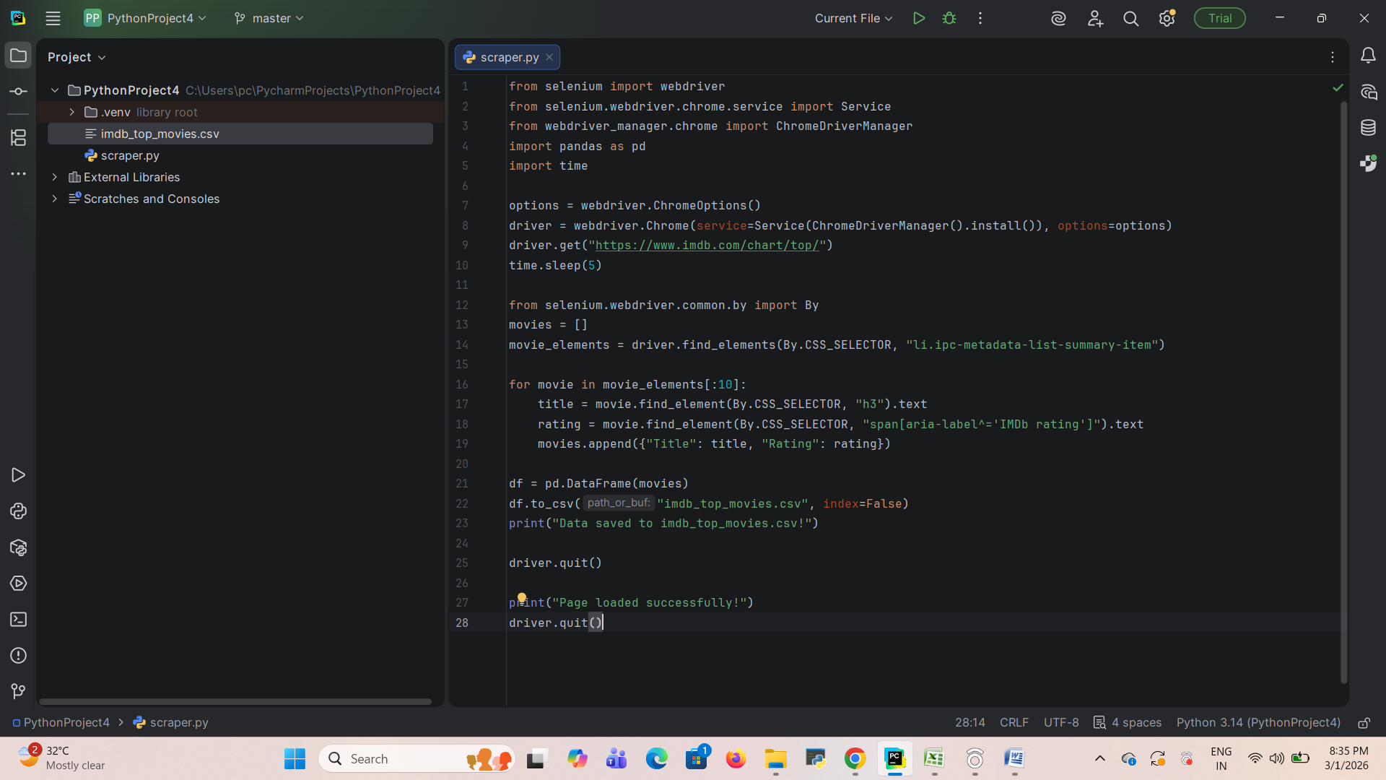
5.Extracted Job Result In Excel:
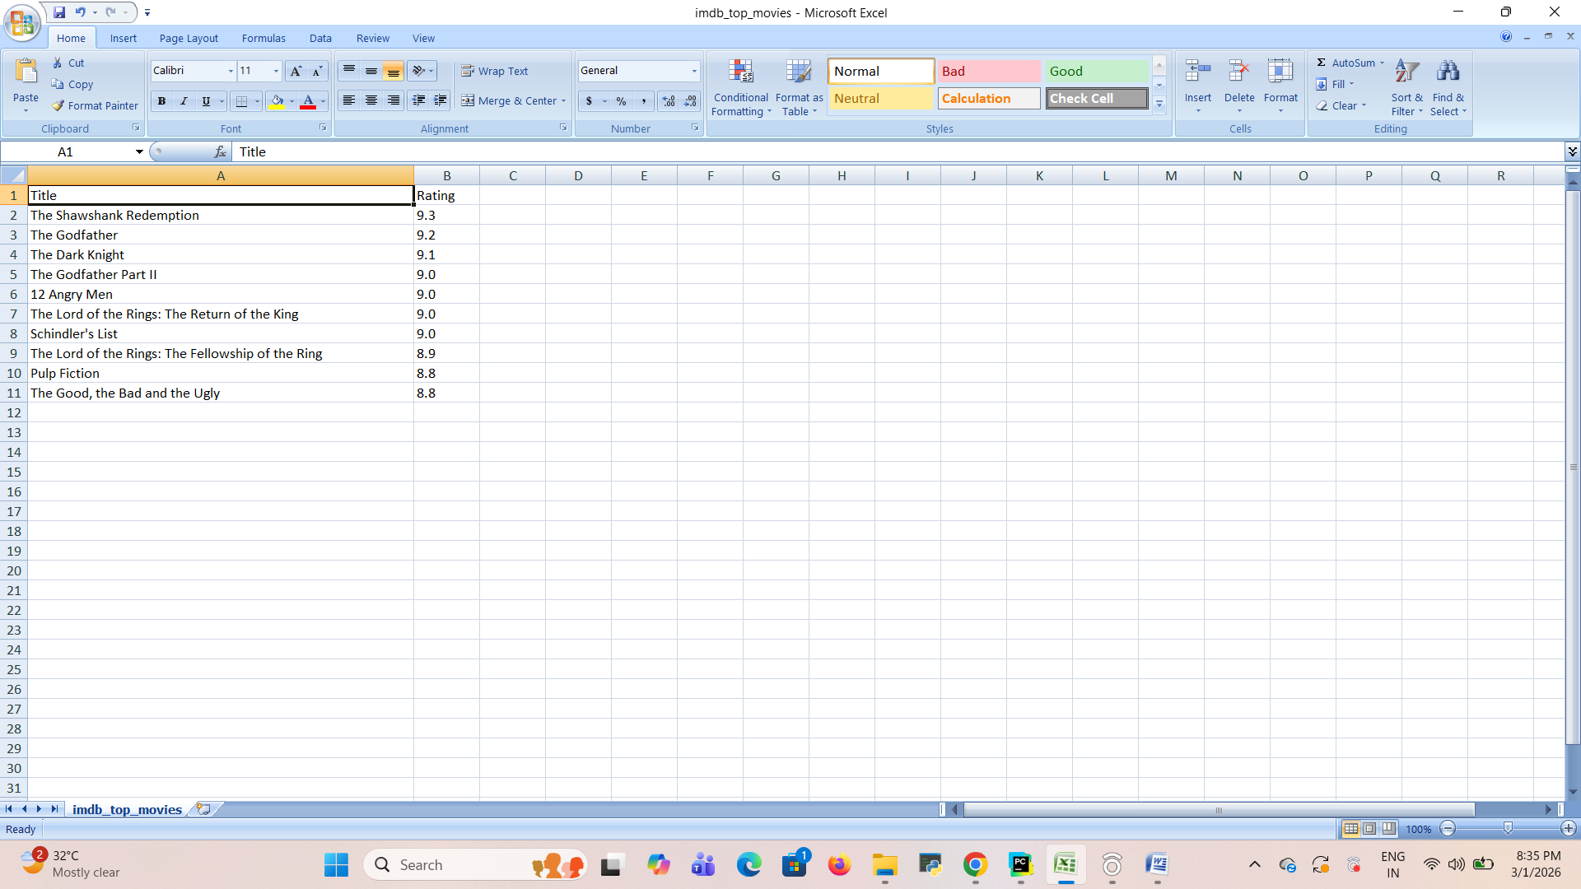

6.KEY ACHIEVEMENTS:

i.Technical Accomplishments
- Dynamic Content Resolution: Successfully implemented Selenium to navigate and render JavaScript-heavy elements that traditional static scrapers cannot access.
- Automated Environment Configuration: Integrated webdriver_manager to eliminate manual setup by automatically downloading and managing the correct ChromeDriver versions.
- High-Precision Data Mapping: Developed accurate CSS selector logic to isolate specific metadata, including movie names, release years, and IMDb ratings from complex list structures.
- Optimized Resource Management: Included a Headless Mode feature, allowing the scraper to execute full browser logic without the memory overhead of a visible user interface.
- Structured Data Engineering: Leveraged the pandas library to transform raw web strings into a clean, tabular CSV format ready for immediate analytical use.

ii.Process Automation Benefits
- Elimination of Manual Labor: Replaces the time-consuming task of manually copying movie rankings with a one-click execution script.
- Real-Time Data Consistency: Ensures that the information retrieved is always up-to-date by pulling directly from the live IMDb Top 250 list.
- Scalability and Versatility: Created a framework that is easily extendable to scrape thousands of individual movie pages for deeper insights like cast and genre without rewriting the core engine.
- Data Readiness for Downstream Apps: Produces standardized CSV outputs that are instantly compatible with data science tools, visualization dashboards, and machine learning models.
- Reliable Scheduling: The architecture allows for daily automated runs, enabling the tracking of long-term rating trends and cinematic popularity shifts.

7.LIMITATIONS AND CONSTRAINTS:

i.Current Limitations
- Fixed Data Scope: The current script is hardcoded to retrieve only the top 10 movies from the IMDb Top 250 list.
- Static Attribute Extraction: It is currently limited to scraping only the title and rating, omitting other available metadata such as genre, director, or cast details.
- Single-Page Dependency: The scraper is designed for the "Top 250" chart and cannot automatically navigate to or search for specific movie titles without manual URL modification.
- Wait Time Sensitivity: The tool relies on a fixed time.sleep(5) command, which may be inefficient if the page loads faster or could cause errors if the internet connection is slow and the page takes longer than 5 seconds to render.

ii.Resource Constraints
- Browser Overhead: Because it uses Selenium to launch a full Chrome instance, the tool consumes significantly more CPU and RAM compared to lightweight, request-based scrapers.
- Driver Dependency: The system requires a local installation of the Google Chrome browser and the corresponding WebDriver to function.
- Execution Speed: Selenium operates at the speed of a browser UI; therefore, scraping large volumes of data is notably slower than using asynchronous API calls or static HTML parsers.
- IP Blocking Risks: Frequent, automated requests to IMDb’s servers without proper rotation of user agents or IP addresses may lead to temporary access restrictions or IP flagging.

8. PROJECT IMPACT AND VALUE

i.Immediate Benefits
- Time Efficiency: Replaces manual data entry by automatically extracting movie titles and ratings in seconds.
- Data Accuracy: Eliminates human error in recording rankings and scores by pulling directly from the source HTML.
- Structured Accessibility: Converts unstructured web content into a clean CSV format, making it immediately ready for use in Excel or Google Sheets.
- Dynamic Content Handling: Successfully captures data that is only visible after JavaScript execution, ensuring no information is missed due to page complexity.
- Ease of Use: Features an automated setup using webdriver_manager, allowing users to run the tool without manual driver configuration.

ii.Long-Term Potential
- Trend and Sentiment Analysis: By scheduling daily scrapes, the tool can be used to track rating fluctuations and popularity trends over years.
- Foundation for AI/ML: The exported datasets provide the high-quality, real-world data necessary to train movie recommendation engines or predictive models.
- Personal Database Growth: The tool is designed to be expandable, with the potential to build a massive personal film library including cast, genre, and director details.
- Operational Scalability: The core architecture can be adapted to scrape other sections of IMDb or similar entertainment platforms, broadening its research utility.
- Business Intelligence: Exported data can be integrated into professional dashboards to monitor the performance of film franchises or studio portfolios.

9.CONCLUSION:
The IMDb Movie Rating Scraper is a Python-based automation tool designed to extract real-time data from the IMDb Top 250 Movies list by specifically targeting dynamic web content that requires browser rendering to display correctly. By utilizing Selenium and Chrome WebDriver, the tool mimics human browsing behavior to ensure all JavaScript elements, such as the movie titles, release years, and IMDb ratings, are fully loaded before collection. This approach allows for the reliable extraction of structured data into a CSV format , transforming a manual observation task into a streamlined digital workflow for movie trend analysis or recommendation engines. While the current scope focuses on a single platform and handles resource constraints through an optional headless mode , the architecture remains highly expandable, offering a foundation for users to navigate into individual movie pages for deeper metadata like cast and genre. Ultimately, this project bridges the gap between raw web data and actionable insights, providing immediate efficiency and long-term potential for data science and machine learning applications.

